EXPERIMENT 9: Create a simple cloud software application for Hospital information system for SIMATS Hospital using any Cloud Service Provider to demonstrate SaaS with fields of patient name, age, address, phone, email, Attender name, attender phone, doctor name, diseases, etc.

Step 1: - Go to ZOHO.com

Step 2: - Create and account and log into the account

Step 3: - Create an application

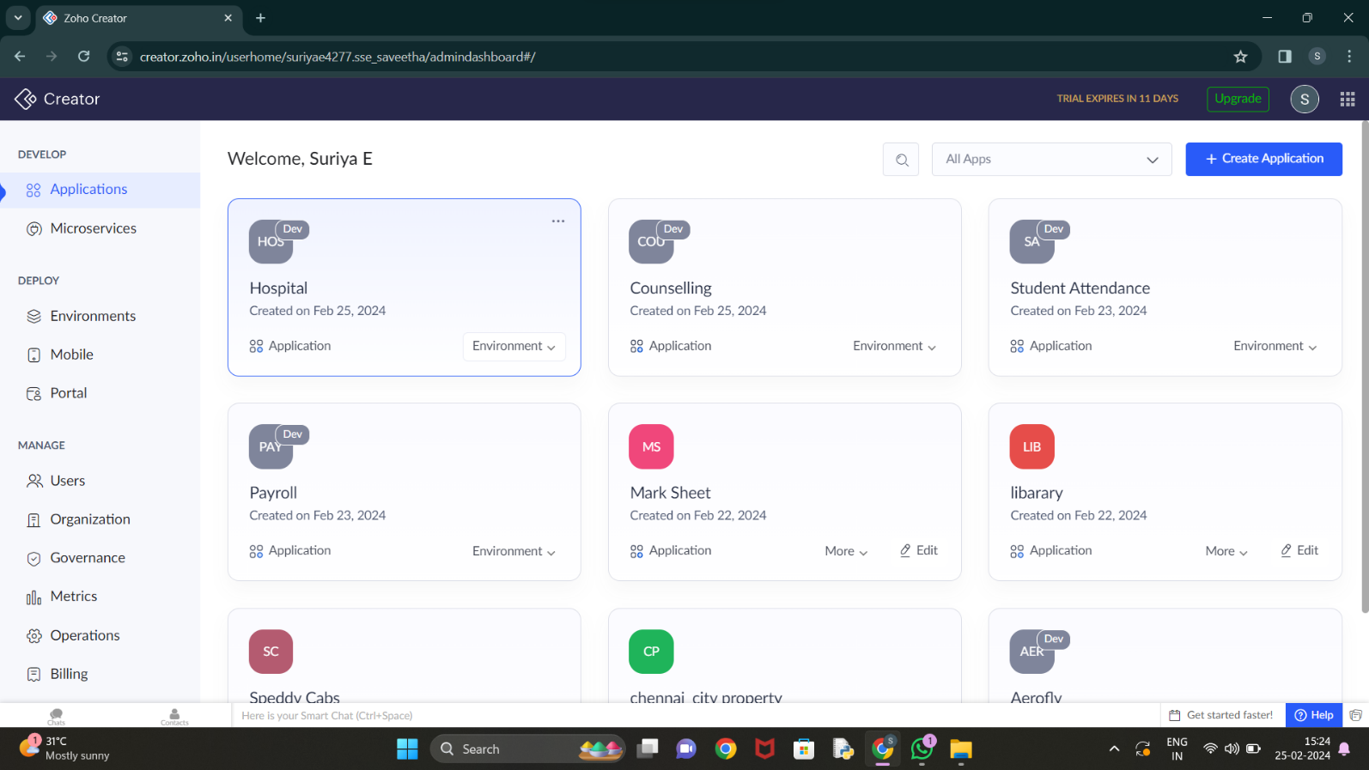

Step 4: - Create login form

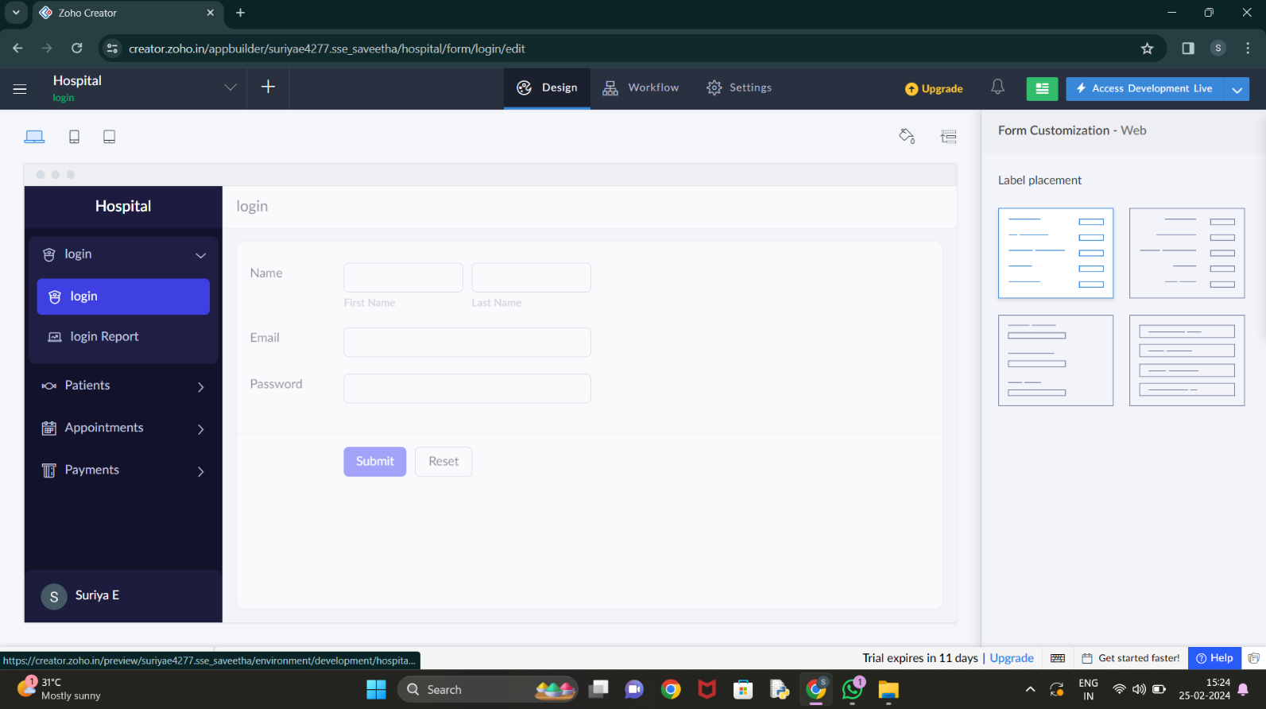

Step 5: - Create form for patient details

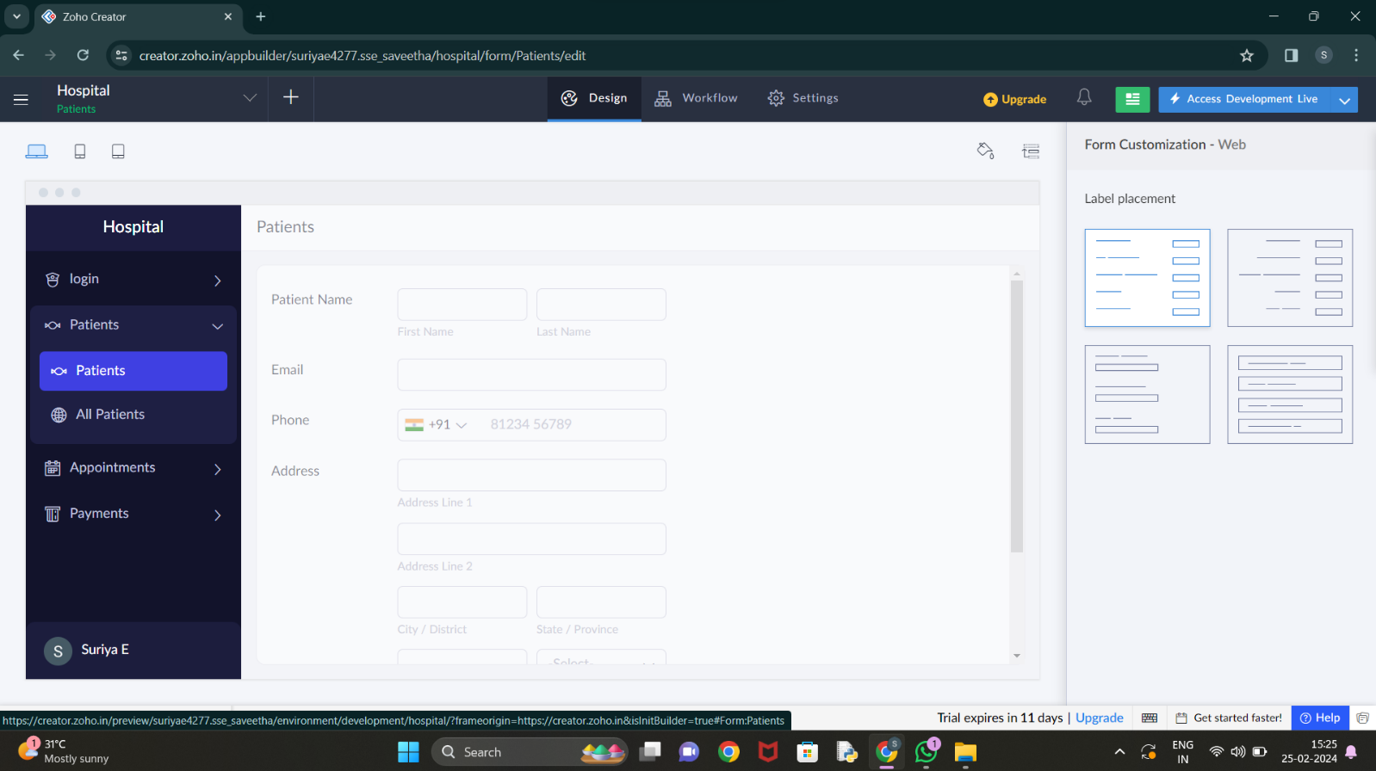

Step 6: - Create form for appointment booking

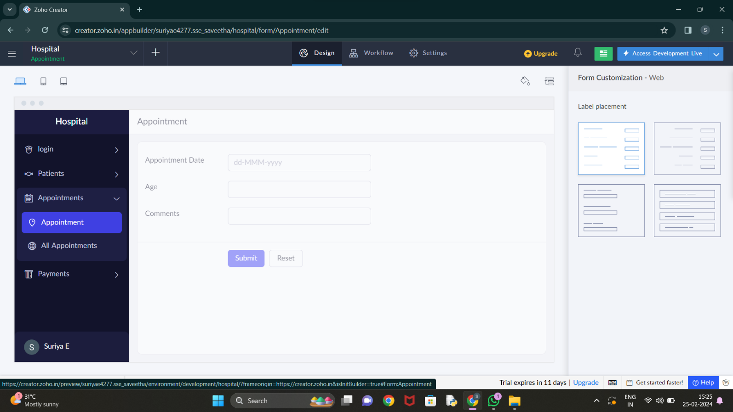

Step 7: - Create form for confirmation of appointment

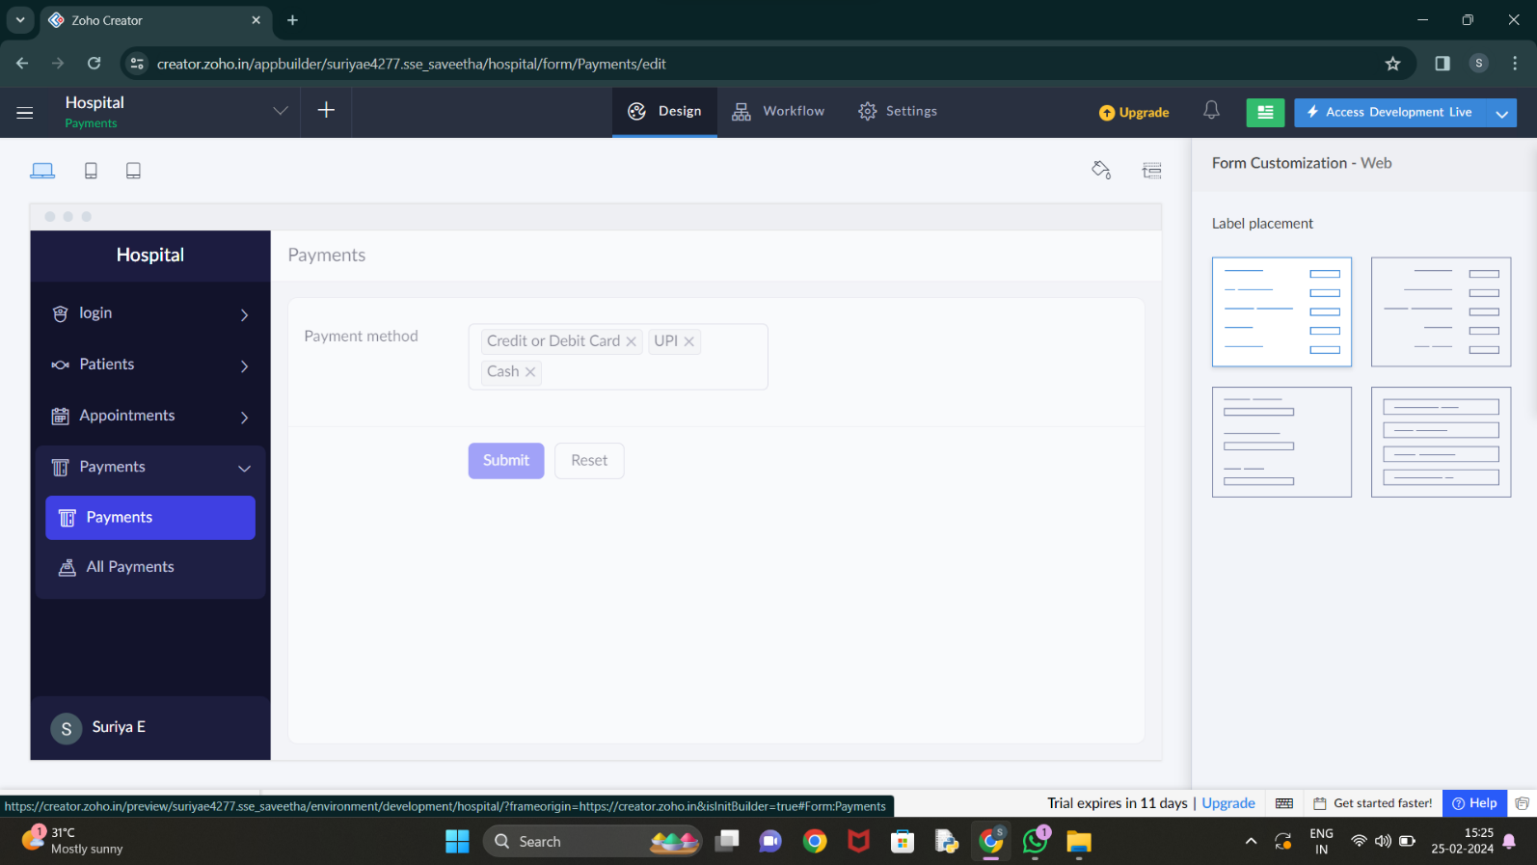

Step 8: - Click on the Access development live to view the output

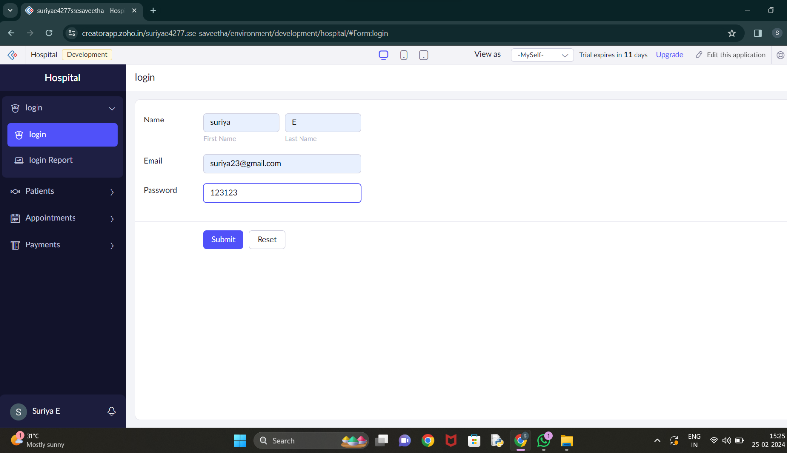

Step 9: - Click on the report to see the saved data’s

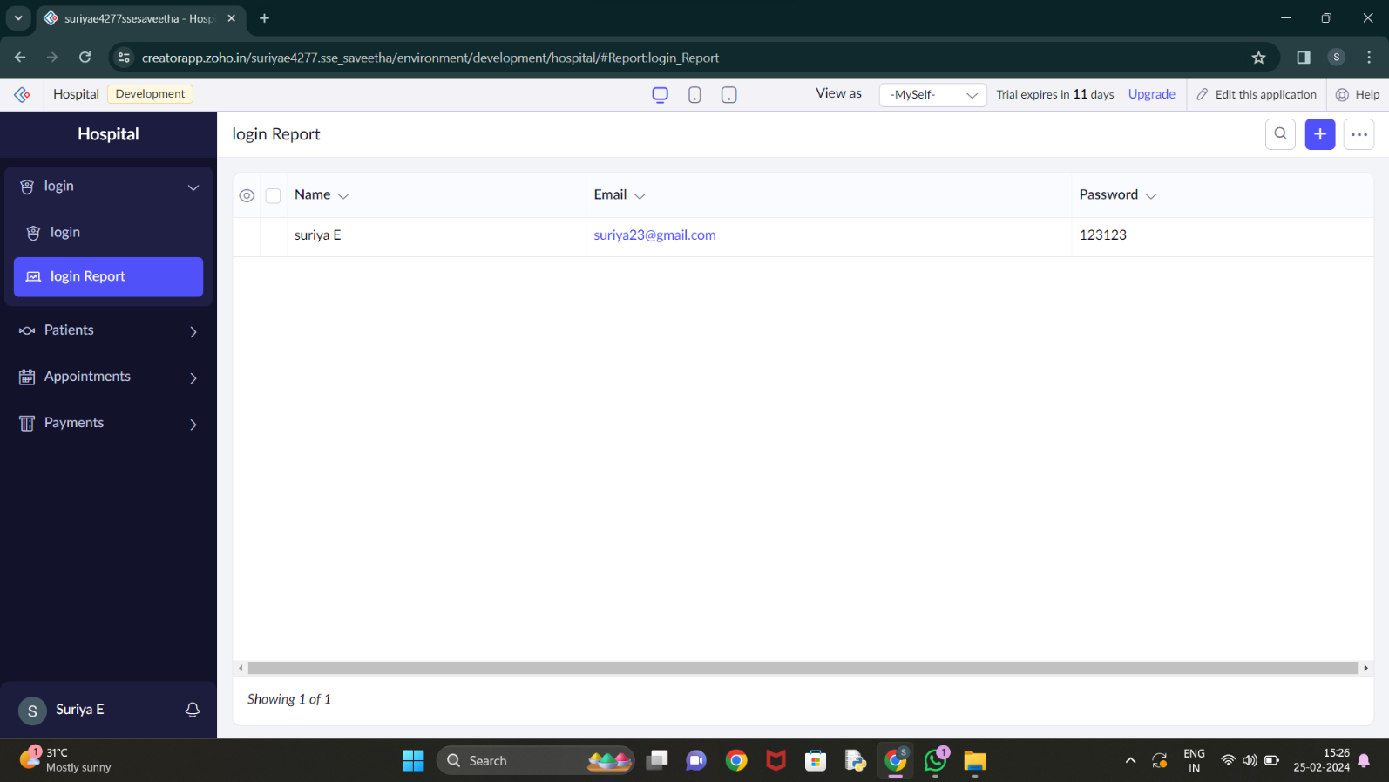

Step 10: - Click on the mobile icon to view the output in mobile format

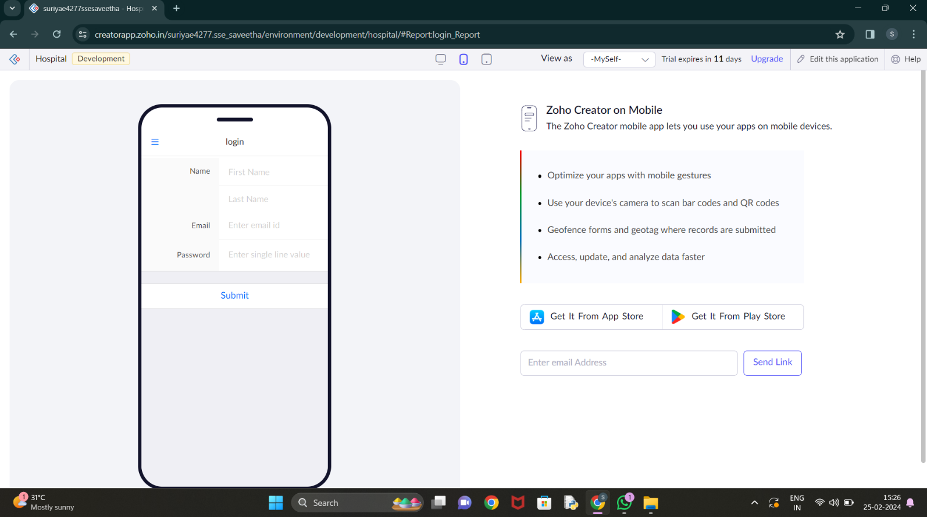

Step 11: - Click on the tablet icon to view the output in tablet format

